Project Design Phase-II
Technology Stack (Architecture & Stack)

Date | 12 September 2026
Project Name | Empolyee Raise Issue
Maximum Marks | 4 Marks

Technical Architecture:
The Employee Raise Issue system is developed using ServiceNow Service Portal and Record Producer. Employees can submit issues through the portal, which creates a record in the Employee Issue table. UI Policies, ACLs, roles, and Flow Designer manage validation, security, assignment, notifications, and issue tracking.
Example: Employee issue reporting and tracking through ServiceNow Service Portal
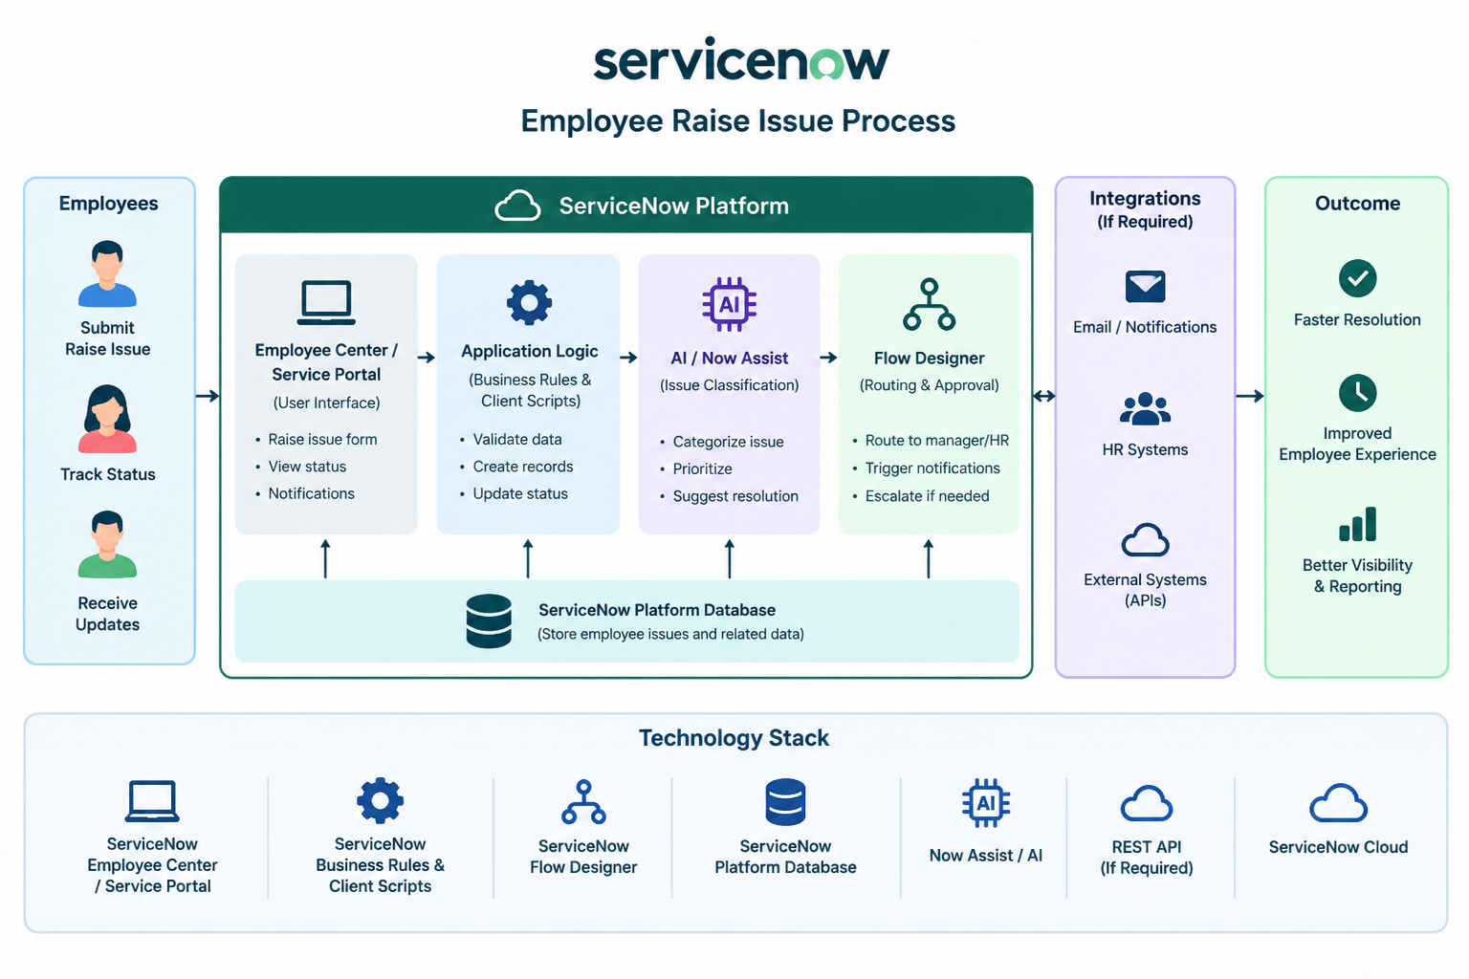

Table-1 : Components & Technologies:
S.No | Component | Description | Technology
 | User Interface | Employees use the portal to raise an issue, select Category and Subcategory, enter details, and track the issue status. . | ServiceNow Employee Center / Service Portal
 | Application Logic-1 | Controls the issue form and validates employee inputs while submitting an issue. | Client Scripts & UI Policies
 | Application Logic-2 | Displays relevant Subcategory choices based on the selected Category. | Dependent Choices / Dictionary Configuration
 | Application Logic-3 | Automatically assigns, routes, updates, and escalates employee issues based on defined conditions. | Business Rules & Flow Designer
 | Database | Stores employee issue records, category, subcategory, description, priority, assignment, and status. | ServiceNow Tables / Platform Database
 | Cloud Database | Provides cloud-based storage and access to employee issue data. | ServiceNow Cloud Platform
 | File Storage | Stores attachments or supporting documents submitted along with employee issues. | ServiceNow Attachments
 | External API-1 | Sends notifications to employees when an issue is created, updated, assigned, or resolved | ServiceNow Email / Notification Service
 | External API-2 | Supports integration with external HR or organizational systems when required. | REST API / IntegrationHub
 | Machine Learning Model | AI can be used to classify issues, suggest categories, prioritize issues, or assist with resolution. | ServiceNow AI / Now Assist
 | Infrastructure (Server / Cloud) | Hosts the Employee Raise Issue application, database, workflows, and integrations. | ServiceNow Cloud Platform .

Table-2: Application Characteristics:
S.No | Characteristics | Description | Technology
 | Open-Source Frameworks | No external open-source framework is required. The application is developed using ServiceNow's built-in platform features. | ServiceNow Platform, JavaScript
 | Security Implementations | Controls employee access to issue records and restricts data based on user roles and permissions. | ServiceNow ACLs, Roles & Permissions, Authentication
 | Scalable Architecture | The application is hosted on the ServiceNow cloud platform and can support multiple employees raising and tracking issues simultaneously. | ServiceNow Cloud Platform, Flow Designer
 | Availability | The application is cloud-based and available to employees through the ServiceNow portal, allowing issues to be raised and tracked without maintaining local servers. | ServiceNow Cloud Infrastructure
 | Performance | Client-side validation, dependent Category–Subcategory choices, automated workflows, and efficient database queries reduce unnecessary processing and improve response time. | Client Scripts, UI Policies, ServiceNow Tables, Flow Designer

